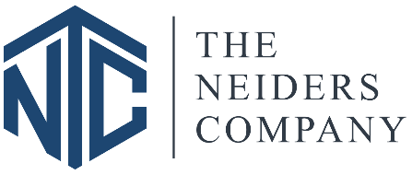

Employee Referral Bonus Form Date: _________________

Thank you for referring the employee listed below and participating in the employee referral program. Please refer to the employee referral program which outlines plan guidelines and eligibility criteria.

The following section is to be completed on-site:

☐ Level 1: Administrative, accounting, leasing, maintenance technician, porter, housekeeper, renovation technician, security, front desk admin — $300
☐ Level 2: Renovation/capital/maintenance supervisor, community manager, district manager, assistant community manager, area manager—$600
☐ Level 3: Regional manager and executive positions— $900

Neiders Company Employee Name (who referred)

Site Manager Date

Date form emailed to accounting:

New Employee Name Date of Hire Position

This section is to be completed by the Human Resources:

Confirmed new hire referred by above employee

Sara (last name) (Human Resources) Date

Process a 1X ------------ bonus with payroll period ending |  |  |  |  | Initial
Process a 1X ------------ bonus with payroll period ending |  |  |  |  | Initial

