Common Cents Instructions:
- Click on the ‘Challenge Ledger’ button to download and save the file to your computer or phone (or print out and keep track throughout the weeks). Be sure to press the save button as you fill out information in the upcoming weeks.
- Each day you are incentivized by points to practice better saving habits. If you achieve this practice by either bringing your lunch to work rather than buying, skipping the morning coffee run and make it at home, use coupons at the grocery store, or any other means of practicing saving money, check the box for that day.
- Keep track of each day and check the box for the entire week, if you manage to check all SEVEN days in the week, check the BONUS box right below for an additional 250 points. See image.
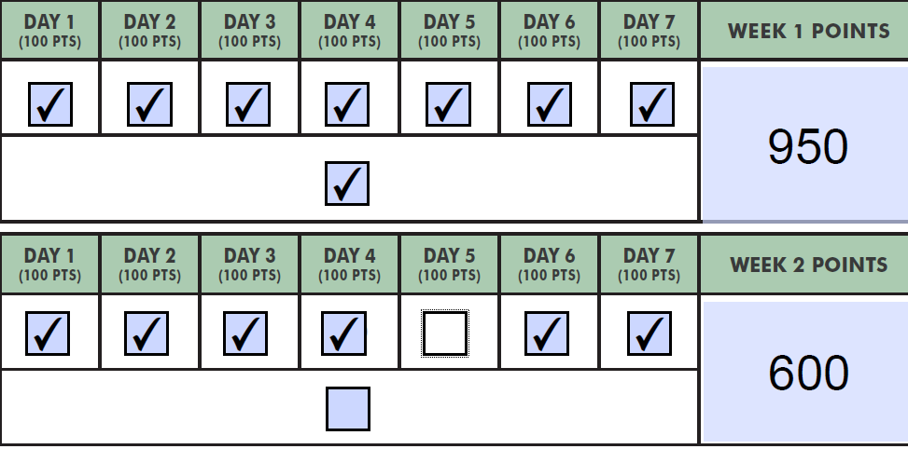
One day missed, so no BONUS is given.
All 7 sevens days, so the BONUS day gets checked.
- Keep track of the ways in which you saved money and track them on page two. Each day you have a checked box, log what you did that day to save money. See image for example.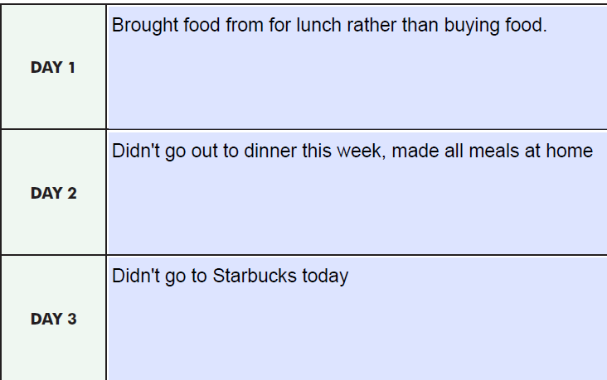
- The four weeks will be from the dates 3/2/2020-3/27/2020. So, for Week 1 Day 1 that would be March 2nd, for Week 2 Day 1 that would be March 9th, and so on. At the end of the four weeks, upload your completed forms to the Let’s Chat page on the Employee portal under ‘Money March’ by 3/31/2020.
If you have any questions please feel free to email BeWell@neiders.com or reach out to Arianna at extension 1000.

Happy Savings!!

